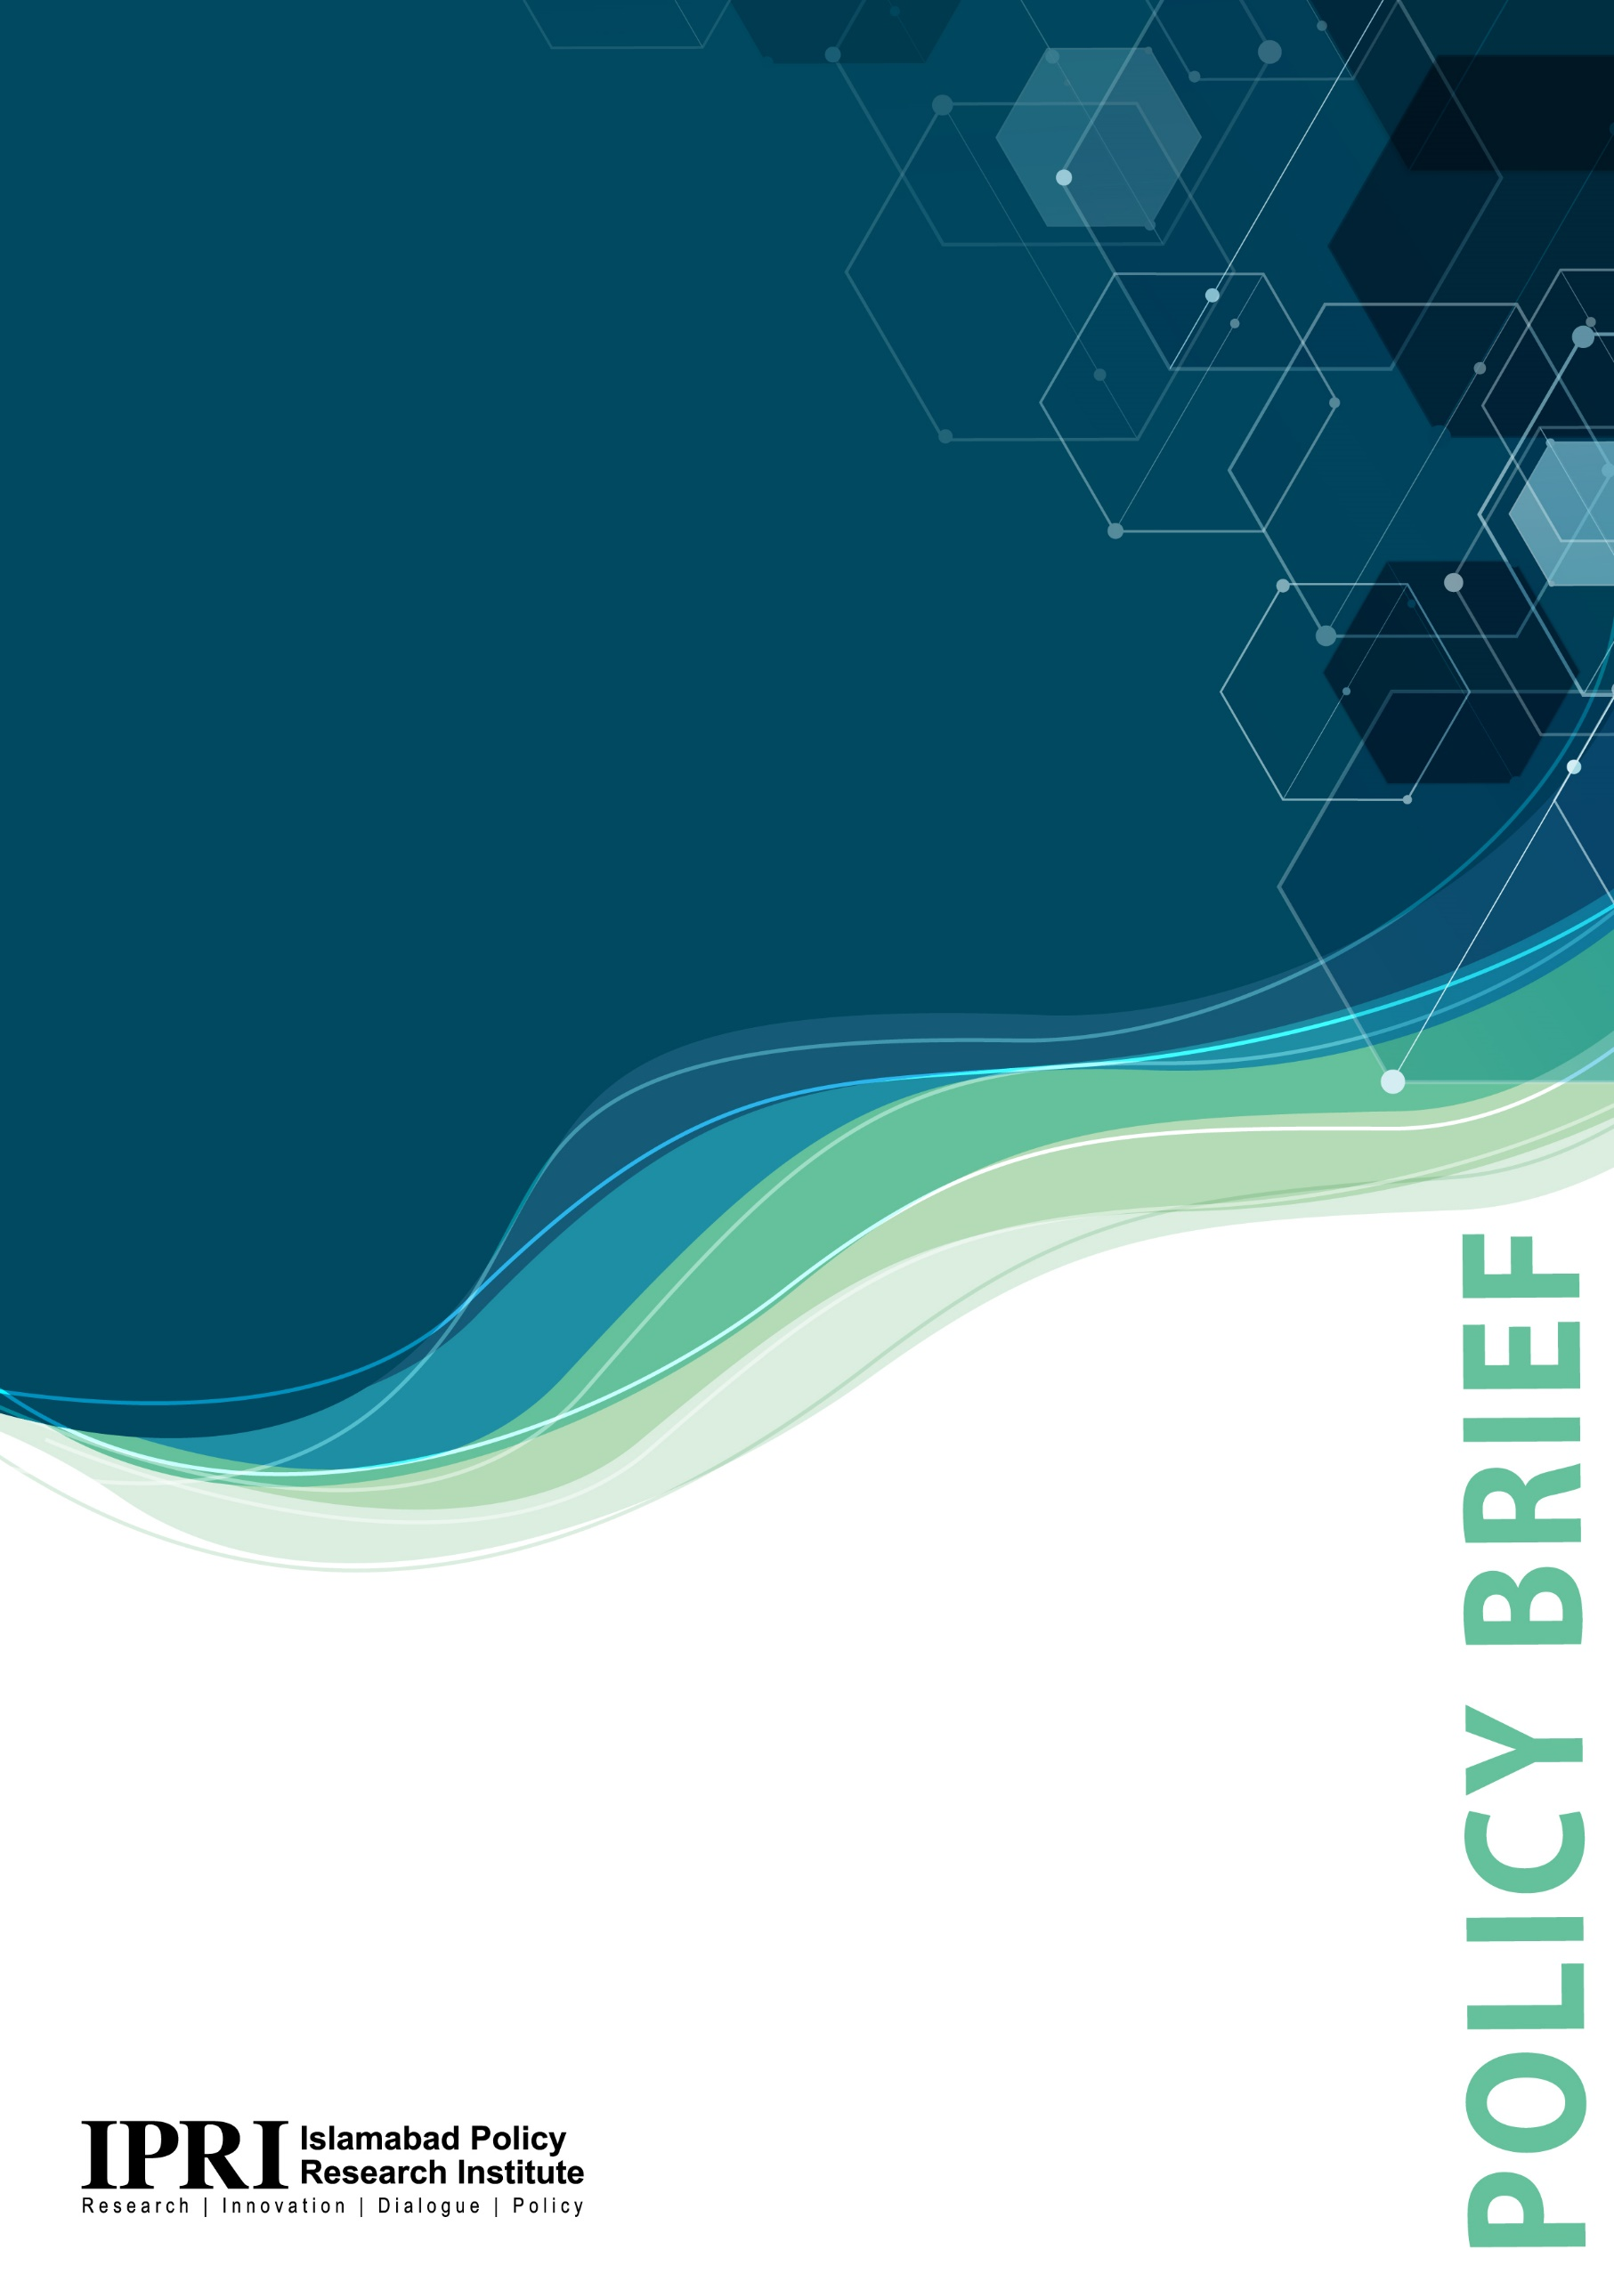
AUKUS- Futuristic military alliance in Indo-Pacific region: Implications on regional and extra regional security conclusions and implications for Pakistan
Hamzah Rifaat Hussain
March 2022
Executive Summary
This policy brief examines the threat that the AUKUS security pact of 2021 has on regional stability and Pakistan. It contends that while the pact is still in its nascent stages, investments in hypersonic missiles, tensions between China, the United States and Australia as well as military modernization efforts coupled with an increase in defense spending pose significant challenges and opportunities for the country. The following recommendations are proposed:-
- Pakistan should condemn unilateral attempts to nuclearize the Asia Pacific through alliances such as AUKUS and make repeated calls for dialogue to deescalate.
- Pakistan should focus its attention on investing in its ‘Vision East Asia Policy’ which seeks greater economic cooperation with ASEAN member states. A commitment to uphold regional connectivity in the absence of military confrontation allows Islamabad to diplomatically convince all sides to eschew military build ups.
- AUKUS is still in its nascent stages and has not been operationalized. Any response from Pakistan must be cognizant of the alliance’s full operability.
- Pakistan must continue to demand an end to American attempts to encourage India to adopt a more assertive role as part of its Indo-Pacific strategy and the Quad alliance as such measures disturb the deterrence equation in South Asia, prompts Indian military modernization and provides an unfair advantage to New Delhi to dictate terms of future military outcomes in East Asia.
- While it is important to stand with China as a strategic partner on regional issues, Pakistan should continue to pursue an official policy of neutrality to avoid souring its relations with countries such as the United Kingdom, the United States and Australia.

Issue to be analyzed
The AUKUS trilateral security pact introduces a new dimension to regional security in the Asia Pacific region. The introduction of nuclear armed hypersonic missiles has wide ranging implications for global security which will also affect Pakistan. This requires adequate diplomatic political and military responses from Islamabad. There is a need to assess the impact of the alliance on global security in general and South Asia in particular.
Analysis
The year 2022 witnessed a major shift in the world security order with the Russian invasion of Ukraine stimulating global arms sales and military modernization efforts among sovereign states. Arms transfers to Ukraine have raised concerns in other parts of the world that existing regional security architectures could be threatened amid increased polarization and tensions between major powers. The Asia Pacific region is no exception to this rule with its territorial security repeatedly threatened by military build ups from the United States, its allies and China over issues such as the independence of Hong Kong, freedom of navigation in South East Asia and the political status of Taiwan. Military tensions have persisted in the year 2022 with a lingering impasse over all historical disputes resulting in a fractured US-China bilateral relationship.
Amid this backdrop, the AUKUS trilateral security pact signed in September 2021 between the United States, the United Kingdom and Australia is of increasing significance as it has a direct impact on regional security in the Asia-Pacific. The pact predates the Russian invasion of Ukraine and is an integral component of the ‘Indo-Pacific’ strategy of the United States. It involves the three countries cooperating on developing quantum technologies, artificial intelligence and cyber security while also allowing Australia to gain access to nuclear powered submarines. The security pact also takes an aim at China given that a joint statement was issued by President Joe Biden Prime Minister Scott Morrison and his British counterpart Boris Johnson at the East Room in Washington D.C., confirming that the alliance is committed to freedom, human dignity, rule of law, respect for sovereignty and a peaceful fellowship of nations by safeguarding regional blocs such as ASEAN and the QUAD. This is despite the fact that the QUAD security dialogue cooperates closely on containing China through military exercises. The announcement of AUKUS resulted in sharp rebukes from the Chinese government which considers it a threat to regional security. Chinese Foreign Minister Wang Yi listed five harms to the region caused by this pact:
- It could trigger the risk of nuclear proliferation.
- It will introduce a new arms race in the region.
- It will undermine regional prosperity and stability.
- It will sabotage the building of a nuclear free zone in Southeast Asia.
- It will to a resurgence of the cold war mentality.
Despite Chinese concerns and rebukes, the security alliance has continued to gain momentum with the United States, the United Kingdom and Australia signing the Exchange of Naval Nuclear Propulsion Information Agreement Treaty ( ENNPIA) in November 2021 which was subsequently ratified by Australia in the same year. The treaty allows for the disclosure of information between the three sides on the use of nuclear powered submarines with the United States also sharing nuclear propulsion technology such as thermal nuclear technology alongside thrusts with twice the propellant efficiency of chemical rockets for military use by the Australian navy. The transfer of such technology makes the security pact instantly controversial with the Economist describing AUKUS as an act of nuclear proliferation from a country which is a signatory to the non-proliferation treaty (NPT). Furthermore, James M. Acton of the Carnegie Endowment for International Peace highlighted the negative implications of the pact on non-proliferation efforts while claiming that it sets a damaging precedent for regional security.
According to the chair of the British Commons’ Foreign Affairs Committee Tom Tugendhat, the merging of military industrial complexes between the three countries as part of AUKUS is a game changing move. The heightened nonproliferation risks and interoperability is further complicated with the introduction of hypersonic missiles in April 2022 which travel five times faster than cruise missiles with greater maneuverability to evade conventional missile defense systems. However, despite the inclusion of additional weaponry, the security pact is yet to be operationalized which has meant that predicting military scenarios is a difficult task. Any assessment can be made based on latest developments in 2022 despite the Asia Pacific region being heavily militarized.
Australia’s inclusion in the controversial security pact has disproportionately affected the deterrence equation in the Asia Pacific as it provides Canberra with nuclear submarines and a mix of cruise missiles and torpedoes which can reach large swathes of Asian Pacific territory. Australia has also announced a separate range of Tomahawk cruise missiles, land based precision strike guided missiles, and airborne joint air- to- surface standoff missiles in September 2021. AUKUS now adds a new dimension to the regional security architecture with Australia already being part of a Trilateral Strategic Dialogue (TSD) with Japan in 2018 with both sides expressing concerns over Chinese expansionism. As expected, China has responded with utter defiance with its growing defense budget indicative of how matters may escalate if investments in AUKUS continue unabated. China’s defense spending has increased by 34.5% from 2014 to 2021. China has also employed its fleet of nuclear powered submarines (SSN) and nuclear armed submarines (SSBN) to maintain a credible minimum deterrent to ward off against the nuclear threat from AUKUS.
Military scenarios heavily depend on US efforts to deploy submarines around the Taiwanese Strait and Washington’s constant push to accelerate the nuclear powered submarines with hypersonic missiles can promote tensions. Deterrence theory however renders any possibility of a nuclear conflict as remote given the massive costs involved and the possibility of the international community intervening and requesting all sides to deescalate. Military scenarios also hinge on the effective management of the trilateral agreement and overcoming bureaucratic hurdles such as classified information and limits on technology transfers for it to become operational.
In light of numerous variables which would define the future operability of the AUKUS alliance, Pakistan’s foreign policy must be cognizant of these realities. The country adheres to an official policy of non-interference while striving to ensure that joint economic cooperation in the presence of an apolitical environment materializes for the entire globe. Pakistan also shares an extensive political, military and economic relationship with China while it’s ‘Vision East Asia’ policy needs to be revived to eschew Westward alignment to benefit from closer cooperation with the ASEAN bloc. According to Ambassador Asif Durrani, Pakistan should monitor the situation in the Indo Pacific closely and denounce the aggressor as the United States continues to interfere in the region.
It is noteworthy that the ASEAN bloc has denounced any attempt to nuclearize the Asia Pacific with vehement opposition to AUKUS expressed in Indonesia and Malaysia. Any escalation as a result of its operationalization which threatens the balance of the Asia Pacific must be condemned with calls to deescalate being a part of foreign policy. The following recommendations are suggested:-
Policy Recommendations
- Pakistan should condemn unilateral attempts to nuclearize the Asia Pacific through alliances such as AUKUS and make repeated calls for dialogue to deescalate.
- Pakistan should focus its attention on investing in its ‘Vision East Asia Policy’ which seeks greater economic cooperation with ASEAN member states. A commitment to uphold regional connectivity in the absence of military confrontation allows Islamabad to diplomatically convince all sides to eschew military build ups.
- AUKUS is still in its nascent stages and has not been operationalized. Any response from Pakistan must be cognizant of the alliance’s full operability.
- Pakistan must continue to demand an end to American attempts to encourage India to adopt a more assertive role as part of its Indo-Pacific strategy and the Quad alliance as such measures disturb the deterrence equation in South Asia, prompts Indian military modernization and provides an unfair advantage to New Delhi to dictate terms of future military outcomes in East Asia.
- While it is important to stand with China as a strategic partner on regional issues, Pakistan should continue to pursue an official policy of neutrality to avoid souring its relations with countries such as the United Kingdom, the United States and Australia.

Matrix Table
Problem | Pathways to Solution | How to Implement Each Solution | Actors Responsible | Implementation Timeline
The AUKUS security pact of 2021 has gained renewed strength with the introduction of hypersonic missiles in 2022. A fractious relationship between the United States, Australia, the United Kingdom and China presents security issues for Pakistan given its geographical proximity to the Asia Pacific. | Exploration of trends in 2022 regarding the operationalization of AUKUS, its viability and whether nuclear deterrence will prevent a conflagration from taking place is the pathway to understanding the security situation. | - Pakistan should continue to pursue its official policy of neutrality and denounce attempts to nuclearize the Asia Pacific region.  - Pakistan’s ‘Vision East Asia Policy’ should be reignited so that economic cooperation with ASEAN member states and the wider region can materialize. A sound East Asia Policy provides Pakistan with greater leverage to conduct shuttle diplomacy.  - Pakistan should constantly monitor developments in the Asia Pacific through the Foreign Office and denounce any attempts by India to become actively involved in undermining deterrence with AUKUS through its participation in the QUAD. | - The Foreign Office.  - Pakistan’s Permanent Representative to the United Nations.  - United Nations General Assembly.  - Shanghai Cooperation Organization. | 6 month time frame.

Fedir Zhuravka, Rostislav Botvinov, Marharyta Parshyna, Tetiana Makarenko and Natalia Nebaba, “ Ukraine’s Integration Into The World Arms Market”, Business Perspectives, Innovative Marketing, Vol. 17, no. 4, (December 2021): 146-155.
Wu Xinbo, “U.S. Security Policy in Asia: Implications for China-U.S. Relations”, Brookings, Working Papers CEAP Visiting Fellows, (September 2000), https://www.brookings.edu/research/u-s-security-policy-in-asia-implications-for-china-u-s-relations/.
Reva Goujon, “It’s Going to Be a Hot Summer for the U.S.- China Relationship”, Foreign Policy, (May 2022), < https://foreignpolicy.com/2022/05/02/us-china-summer-ukraine-trade-biden-xi/>.
? Louisa Brooke-Holland, John Curtis and Claire Mills, “ The AUKUS agreement”, Library of the House of Commons, No. 09335, p. 5.
"Fact Sheet: Implementation of the Australia – United Kingdom – United States Partnership (AUKUS)", Prime Minister of Australia, Press release, 6 April, 2022.
Official Joint Leaders Statement on AUKUS, The White House Briefing Room, (September 2021), https://www.whitehouse.gov/briefing-room/statements-releases/2021/09/15/joint-leaders-statement-on-aukus/.
Amrita Jash, “The Quad Factor in the Indo-Pacific and the Role of India”, Journal of Indo- Pacific Affairs, (Spring 2021), pp.78-84.
Huaxia, “AUKUS nuclear submarine deal brings give harms to region, says Chinese FM”, Xinhua Net, 29.09.2021.
In Focus, “AUKUS agreement to exchange naval nuclear propulsion information”, House of Lords Library, UK Parliament, (January 2022), https://lordslibrary.parliament.uk/aukus-agreement-to-exchange-naval-nuclear-propulsion-information/.
Fatima Bahtic, “AUKUS partners ready to exchange naval nuclear propulsion information”, Naval Today, (February 2022), https://www.navaltoday.com/2022/02/22/aukus-partners-ready-to-exchange-naval-nuclear-propulsion-information/.
The Economist, “What does the Australian submarine deal mean for non-proliferation”, International, (September 2021), https://www.economist.com/international/2021/09/17/what-does-the-australian-submarine-deal-mean-for-non-proliferation.
James M. Acton,” Why the AUKUS Submarine Deal Is Bad for Nonproliferation – And What to Do About it”, Carnegie Endowment for International Peace, (September 2021), https://carnegieendowment.org/2021/09/21/why-aukus-submarine-deal-is-bad-for-nonproliferation-and-what-to-do-about-it-pub-85399.
Paul Dempsey, “View from Washington: AUKUS looms over AI and quantum”, Engineering and Technology, Comment, (September 2021), https://eandt.theiet.org/content/articles/2021/09/view-from-washington-aukus-looms-over-ai-and-quantum/.
The Economist, “AUKUS, a strategic submarine pact, turns to missiles”, Asia, (April 2022), https://www.economist.com/international/2021/09/17/what-does-the-australian-submarine-deal-mean-for-non-proliferation.
Nose Nobuyuki, “The Formation of AUKUS and Australia’s Path to Its First Nuclear Submarine”, Nippon, World, (December 2021), https://www.nippon.com/en/in-depth/d00766/.
Richard R. Burgess, “AUKUS Agreement Will Provide Tomahawk Missiles to Australian Navy”, Sea power, (November 2021), https://seapowermagazine.org/aukus-agreement-will-provide-tomahawk-missiles-to-australian-navy/.
William T. Tow, “The Trilateral Strategic Dialogue, Minilateralism, and Asia Pacific Order Building”, Stimson Center, 2015, pp. 23-24.
Evelyn Cheng, “China will raise defense spending by 7.1% in 2022, faster than last year”, CNBC, (March 2022), https://www.cnbc.com/2022/03/05/china-defense-spending-to-rise-by-7point1percent-in-2022-says-finance-ministry.html.
Liu Zhen, “The underwater arms race: China. Aukus and a deepening submarine rivalry”, South China Morning Post, (October 2021).
Saman Rizwan, “Reviving Pakistan’s Vision East Asia Policy”, Centre for Strategic and Contemporary Research, (October 2020), https://cscr.pk/explore/themes/trade-economics/reviving-pakistans-vision-east-asia-policy/.
Ambassador Asif Durrani in discussion with the author, May 2022.
Asia Pacific, “Indonesia, Malaysia concerned over AUKUS nuclear subs plan”, Reuters, (October 2021), https://www.reuters.com/world/asia-pacific/indonesia-malaysia-start-work-travel-corridor-2021-10-18/.

